Day 5 – Internet Archives

1. Wayback Machine
The Wayback Machine is a digital archive of the World Wide Web developed by the Internet Archive. It stores snapshots of websites taken on different dates, allowing users to view how a website looked in the past.

Why is it useful?
- Recover deleted web pages
- View previous versions of websites
- Track changes in content
- Verify historical information
- Support OSINT investigations
Example:
A company removes an announcement from its website. Using the Wayback Machine, an investigator may still be able to view the archived version.

2. Cached Pages

What are Cached Pages?
A cached page is a temporary copy of a webpage stored by search engines such as Google or Bing. If a website is temporarily unavailable, the cached version may still be accessible.

Why are they useful?
- Access unavailable websites
- Compare recent changes
- Retrieve recently removed information
Note: Cached pages usually store only the most recent version, whereas the Wayback Machine stores historical versions over many years.

3. Deleted Websites

What are Deleted Websites?
Sometimes websites are removed or domains expire. Even though the live website is no longer available, archived copies may still exist.

Importance
Investigators can use archived copies to:
- Recover historical content
- Analyze previous business information
- Verify old announcements
- Investigate cyber incidents

4. Historical Analysis

What is Historical Analysis?
Historical analysis means comparing different archived versions of a website to understand how it has changed over time.
Changes may include:
- New products
- Updated services
- Security notices
- Contact information
- Company branding
- Leadership changes
Historical analysis helps investigators understand the evolution of an organization.

Practical Exercise – Comparing Three Archived Websites

Selected Websites
- OpenAI
- Wikipedia
- NASA

Website 1 – OpenAI
Website: https://openai.com

Observation
- Older versions had fewer products and simpler navigation.
- Recent versions include ChatGPT, API platform, research, pricing, and developer resources.
- The homepage has become more interactive and product-focused.

Findings
OpenAI has expanded significantly, reflecting its growth in AI research and commercial products.

Website 2 – NASA
Website: https://www.nasa.gov

Observation
- Earlier versions focused mainly on mission updates.
- Current versions include multimedia content, interactive features, educational resources, and improved navigation.

Findings
NASA's website has evolved to improve accessibility and public engagement.

Website 3 – Wikipedia
Website: https://www.wikipedia.org

Observation
- Earlier versions of the homepage had a simpler design with fewer language options and basic navigation.
- The current website offers a cleaner interface, improved search functionality, better accessibility, and support for many more languages.
- The overall layout has been optimized for both desktop and mobile users while keeping its familiar appearance.

Findings
Wikipedia has continuously improved its user experience while maintaining its primary goal of providing free and accessible knowledge. The archived versions show gradual improvements in design, language support, and usability rather than major changes in purpose.

Comparison of Three Archived Websites
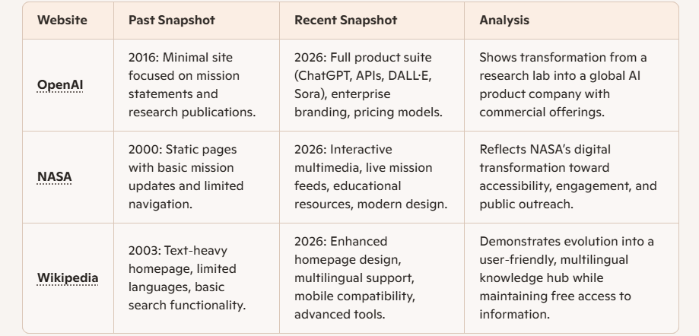

Conclusion
- Internet archives are powerful for recovering deleted content, tracking organizational growth, and conducting historical analysis.
- Comparing OpenAI, Wikipedia, and NASA shows how organizations evolve digitally over time.
- For OSINT, archives provide evidence trails and help verify authenticity.

